**Course Title: Digital Logic and System Design**

**Course Code: CSE 210**

**Credit Hour: 1.5**

**Experiment No. 3**

**Experiment Name:**

**Test and verify the universality of -**

**a) NAND gate**

**b) NOR gate**

**Tasks:**

Implement the basic logic gates with only NAND or NOR gates –

a) AND

b) OR : A + B = ((A.A)’ . (B.B)’)’

c) NAND

d) NOR

e) XOR

f) NOT : A’ = (A.A)’

**Circuit diagram:**

Using NAND gates -

|  |
| --- |
|  |

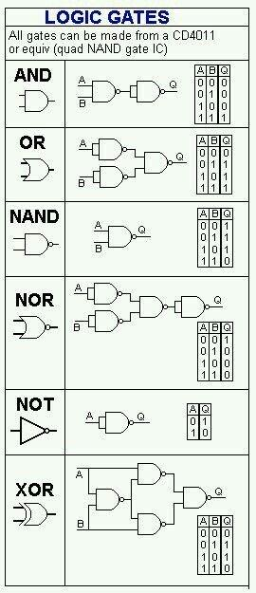

Using NOR gates –

(Design it yourself)

**Report:**

1) Problem Statement

2) Instruments (used in this experiment)

3) Truth Table

4) Logic expression

5) Logic diagram

6) Discussion